Safe and Efficient Traffic Obstacle Detection using Fine-tuned Modified Faster R-CNN
Jyoti Madake¹[0000-1111-2222-3333], Shruti Korpade²[1111-2222-3333-4444], Hemal Kulkarni³[2222-3333-4444-5555], Rahul Kumbhar⁴[3333-4444-5555-6666], Shripad Bhatlawande⁵[4444-5555-6666-7777]
¹ Department of Electronics and Telecommunication Engineering, Vishwakarma Institute of Technology, Pune, 411037, Maharashtra, India
² Springer Heidelberg, Tiergartenstr. 17, 69121 Heidelberg, Germany
lncs@springer.com
Abstract. The proposed Fine-tuned Modified Faster R-CNN (Region-Based Convolutional Neural Network) implementation system uses computer vision and deep learning to improve the effectiveness and safety of traffic obstacle identification. This automated system uses machine learning algorithms based on the ResNet-50 architecture. A dataset of images of bikes, pedestrians, traffic signals, and cars, are used for training and testing. Accurate traffic element identification and localization are made possible by the Faster R-CNN object detection model. The model's performance is improved by the application of strategies including Stochastic Gradient Descent, Cross-Entropy, and Fine-tuning, yielding an accuracy rate of 98.26%. In real-time circumstances, the model creates precise bounding boxes around things it detects, opening the door to a more automated and secure transportation system. The proposed model is compared with other object detection models like Fast R-CNN, R-CNN, YOLOv5, SSD, RetinaNet based on five parameters: Accuracy (mAP), Latency, Model Size, Dataset, Bounded box loss. The comparative analysis shows superior accuracy compared to existing systems.
Keywords: Traffic Obstacle Detection, Faster R-CNN, ResNet-50, Stochastic Gradient Descent, Fine-tuning
- Introduction
Road users such as cyclists and pedestrians are difficult to recognize and classify for traffic obstacle recognition systems because of a variety of elements, including diverse sizes, fluid motions, congested settings, challenging illumination, contextual awareness, inclement weather, and different apparel. It is challenging for detection models to generalize across many situations due to these problems. Accurate detection and tracking can become increasingly tough in populous places due to dynamic movements, congested spaces, and adverse lighting conditions. In addition to being essential for safe obstacle detection, contextual awareness can be made even more difficult by adverse weather conditions. One of the challenges is small datasets for pedestrian and cyclist detection. Further research on sensor technologies, computer vision, and machine learning techniques is needed to address these issues. Improved traffic obstacle detection systems are crucial for autonomous cars, intelligent transportation systems, and road safety campaigns.
The potential transformational effects on traffic management, road safety, and the realization of a more inclusive and adaptable transportation ecosystem are the driving forces behind the development of a safe traffic obstacle detection system. The identification and prediction of pedestrian and cycling behavior can be improved, leading to a decrease in fatalities and an increase in overall road safety. This technology allows autonomous vehicles to be able to operate in harmony with human traffic. In addition, it guarantees inclusiveness in transit while maximizing traffic flow and negotiating challenging circumstances. Thus, removing these obstacles advances sensor, computer vision, and machine learning technologies while also boosting public confidence in technology. A well-functioning system has worldwide consequences for urban planning, offering important perspectives for developing safer, more pedestrian-friendly settings. The desire to see technologically improved, safer, more accessible, and seamlessly integrated roads in the future drives efforts to overcome obstacles and create a reliable and efficient system. [2].
The proposed solution to develop an Enhanced Traffic Obstacle Detection through Fine-tuned Faster R-CNN with ResNet-50 Architecture is an inventive attempt at intelligent traffic management. The model leverages the ResNet-50 architecture, which is based on the Faster R-CNN framework, to improve its performance in identifying minute details in the traffic environment. This allows for dependable object detection. The system stands out for its commitment to fine-tuning, a laborious process of improvement that leads to a more advanced understanding and recognition of traffic obstructions. This work, with its combination of ResNet-50, Faster R-CNN, and fine-tuning techniques, places the system at the forefront of intelligent traffic detection. This method ensures speed and accuracy in traffic obstacle detection, promising a paradigm shift in the field. The system intends to pave the way for a more effective and safe future in traffic management by making the road a safer, smarter, and more responsive place for all users.
- Literature Survey
Autonomous driving technology represents a groundbreaking frontier in transportation, with recent developments focusing on enhancing scene interpretation, object detection, and traffic management. This survey delves into various research endeavors, highlighting the strides made and identifying areas for further exploration.
A notable advancement lies in probabilistic 3D scene modeling, which incorporates geometric reasoning, object tracking, and multiclass object recognition [1]. This sophisticated model facilitates the joint recovery of 3D scene context and multi-object tracking using monocular video input, even in scenarios with complex object interactions such as occlusion and physical exclusion. Additionally, a picture captioning model has been introduced for traffic scene interpretation, employing Long Short-Term Memory Network (LSTM) to provide natural language descriptions [2].
Efforts to design visually appealing traffic signs have also garnered attention, emphasizing the importance of leveraging color components to address segmentation issues in complex traffic scenes [3]. Alongside this, novel traffic scene recognition systems employing Convolutional Neural Networks (CNNs) and Vector of Locally Aggregated Descriptors (VLAD codes) aim to enhance traffic flow and replicate human perception [10].
In the realm of object detection, Faster R-CNN ResNet50 has emerged as a frontrunner, striking a balance between processing speed and accuracy [5]. Region-based convolutional neural networks (RCNNs) have also demonstrated efficacy in autonomous moving vehicle identification and recognition, achieving high accuracy rates [6].
Intelligent Vehicle Systems (ITS) necessitate robust vehicle recognition and segmentation systems. Studies have shown the effectiveness of methods such as Faster RCNN in achieving high accuracy and processing speeds [7]. Instance segmentation techniques like Mask R-CNN have proven useful for vehicle recognition, combining quick detection with excellent accuracy [8, 9].
Deep learning plays a pivotal role in vehicle type detection, surpassing the limitations of traditional methods [10]. Moreover, a fast multi-task CNN has been developed for effective traffic scene detection, crucial for applications like automated driving [12].
Recent advancements include the development of frameworks for comprehensive scene interpretation from monocular videos, leveraging techniques such as semantic segmentation [14]. Additionally, adaptive traffic forecast methods have been proposed to improve the accuracy of real-time Variable Bit Rate (VBR) MPEG videos [15].
In robotics applications, benchmarks have been established for tasks like 3D object detection and visual odometry/SLAM using autonomous driving platforms, aiding in reducing overfitting and enhancing assessment standards [16]. Sensor fusion techniques, integrating camera footage, motion sensors, and 3D semantic maps, contribute to robust self-localization and segmentation, enhancing system dependability [17].
Datasets like ApolloScape offer extensive resources for research, with dense 3D point clouds and semantic masks aiding in various tasks [18]. Vehicle detection benefits from the fusion of camera and LiDAR data, employing algorithms like RANSAC and DBSCAN [19].
In the realm of traffic control, CNN models implemented on platforms like Raspberry Pi offer real-time decision-making capabilities, facilitating the swift passage of emergency vehicles [20]. Furthermore, multi-sensor fusion proves instrumental in addressing challenges associated with motion-based object segmentation in urban environments [21].
"Deep learning for object detection and scene perception in self-driving cars" provides a comprehensive overview of deep learning applications in autonomous vehicles, highlighting challenges such as real-time processing and safety concerns [22].
In conclusion, while significant progress has been made in autonomous driving research, there remain opportunities for advancement. Improved forecast accuracy for specific vehicle colors and enhanced training and detection speeds for advanced models are imperative for practical application [8, 10]. This survey serves as a roadmap for future research endeavors, aiming to bridge existing gaps and propel the field towards even greater advancements.
- Proposed System
The Traffic Obstacle Detection using Fine-tuned Modified Faster R-CNN system can be used by individuals in daily life and would be beneficial for people traveling by road (see Fig. 1). It takes a given image and applies an algorithm to extract information, from which it predicts the class to which the object belongs. Thereby, providing a clear number of vehicles present in the image. System stores the information of those features in a .pth file and uses it for testing and predicting the class in any provided image.

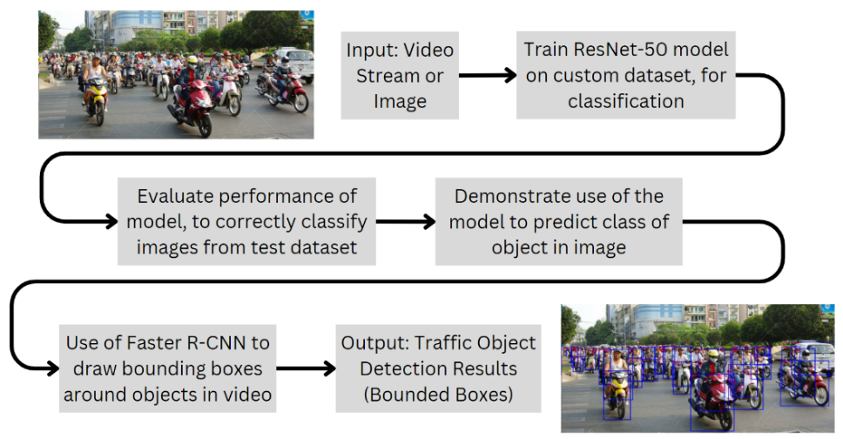
Fig. 1. Overall System Architecture Block Diagram for this proposed solution
- Methodology
This paper proposes a system for traffic object detection using the ResNet-50 architecture. The model is built using Faster R-CNN architecture for detecting zebra crossings, traffic signs, cars, bikes, and pedestrians. The model predicts traffic flow and can adjust traffic signal timings, improving transportation efficiency. The model has undergone rigorous training over 100 epochs, incorporating optimizers like SGD, Cross Entropy, and Fine-tuning. Comparative analysis shows superior accuracy compared to existing systems. The approach also incorporates dynamic elements, allowing real-time bounding boxes for video inputs, enhancing adaptability and responsiveness.

  - Dataset Details:
The dataset is imported from several publicly accessible datasets [23]. The images are brought in as JPG files. 692 of the 3709 photos are chosen for testing the data, and the remaining 3017 are used for training. Five labels— zebra crossings, traffic signs, cars, bikes, and pedestrians—make up the training and testing dataset (see Fig. 2). The classes mentioned in Table 1 are used in this proposed solution.
Table 1. Dataset details
Sr. No. | Classes | No. of Training Images | No. of Testing Images
1 | Pedestrians | 944 | 235
2 | Traffic Signs | 551 | 162
3 | Cars | 1015 | 177
4 | Bikes | 331 | 82
5 | Zebra Crossing | 176 | 36
 | Total | 3017 | 692

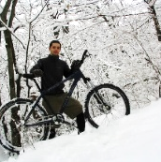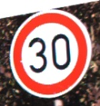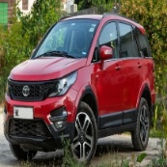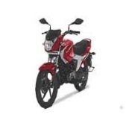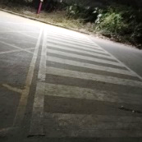
(a) (b) (c) (d) (e)
Fig. 2. Examples from each of the five classes: Pedestrians (a), Traffic signs (b), Cars (c), Bikes (d), and Zebra crossings (e).
  - Preprocessing and Feature extraction
The algorithm uses a series of data transformations to preprocess the training dataset for feature extraction using a pre-trained ResNet-50 model. These transformations include RandomResizedCrop, RandomHorizontalFlip, ToTensor, and Normalize. These transformations enhance the model's robustness and generalization capabilities. A DataLoader is created to efficiently load batches from the preprocessed dataset, avoiding overfitting and using multiple workers for parallel data loading. The pre-trained ResNet-50 model is loaded, providing a feature extraction backbone that leverages knowledge from training on a large dataset. This model serves as a foundation for further fine-tuning or training specific to the task. It considers three-channel RGB image pre-processing and feature extraction.

  - Fine-tuning of Traffic Obstacle Detection

Fine-tuning with SGD. A deep learning optimization technique called Stochastic Gradient Descent (SGD) updates weights and maximizes efficiency by minimizing the cost function at the end of each iteration. It introduces fluctuations in the objective function, potentially causing the gradient to jump towards a global minimum. Transfer learning in deep learning involves enhancing weights, fine-tuning neural networks, or adding "adapters" with fewer parameters. For better results, it is usual to refine complete pre-trained models; however, this comes with higher computing costs.
The basic update rule for SGD can be expressed as follows:
θt + 1 = θt − η⋅∇J (θt; x(i), y(i)) (1)
Equation (1) involves parameters θt, learning rate η, input features x(i), output y(i), cost function J(θt; x(i), y(i)), and gradient of cost function with respect to parameters θt.
It measures the difference between predicted and actual output for a given training example, and the direction and magnitude of the steepest increase in the cost function.

Loss minimization using Cross Entropy. An extension of information theory entropy is the concept of cross entropy, which quantifies the difference between two probability distributions for a given random variable or set of events. Throughout training, model weight adjustments are made via cross-entropy loss. The goal is to reduce the loss; a better model has a lesser loss. Cross-entropy loss in a perfect model is 0. Multi-class and multi-label classifications are usually supported. Cross-entropy loss quantifies the discrepancy between the probability distribution discovered and the one anticipated by a deep learning classification model. Equation (2) states that the cross-entropy between two probability distributions, such as Q from P, is formalized as H (P, Q), where P may represent the target distribution, Q is an approximation of the target distribution, and H() is the cross-entropy function.
One can compute cross-entropy by utilizing the event probabilities from P and Q.
H (P, Q) = log(Q(x)) * Sum x in X (P(x)) (2)
Before computing the CE loss, the scores are usually run via an activation function (Sigmoid/Softmax).
With Softmax, the model forecasts a vector of probabilities [0.7, 0.2, 0.1]. Since the sum of 70%, 20%, and 10% equals 100%, the most likely entry is the first one.
This system considers the below Algorithm 1 which is based on optimizing the Fine-tuned Modified Faster R-CNN Model along with SGD.

Algorithm 1 Fine-tuning ResNet-50 for Traffic Obstacle Detection
Input: Dataset of Training Images
Output: Extracted Features and Trained Model

- For each parameter of the ResNet50 model, set tensor gradient calculation requirement← False (Freeze all layers)
- For each parameter of the 4th layer of the model, tensor gradient calculation requirement ← True (Unfreeze the last residual block)
- Modify fully connected layer of the model ← output that corresponds to the number of classes to be predicted (number of classes = 5)
Loss and Optimizer:
- Define loss function: criterion ← Cross Entropy Loss
- Define optimizer: optimizer ← SGD (filtering parameters that require updated gradients, learning rate = 0.001, momentum = 0.9)
Training Loop:
- For epoch from 1 to 100
  - Set model in training mode
  - Initialise running loss
  - For each (inputs, labels) in batches of training data
- Performs a forward pass through the model to obtain predictions
- Computing loss by comparing the model's predictions (outputs) to the labels
- Performs the backward pass
- Update the model parameters based on the computed gradients
- running_loss += loss.item() × inputs.size(0)
  - Average loss for each epoch ← running_loss / len (train_dataset)
  - Append average loss to the train_losses list:
train_losses.append (epoch_loss)
_____________________________________________________________________

  - Safe and Efficient Traffic Obstacles Detection Model Flowchart:
The flowchart for safe and efficient traffic obstacle detection is shown below (see Fig. 3). The training dataset of video streams used to train the Faster R-CNN model is refined by the ResNet-50 backbone network to improve the model's accuracy and efficiency in traffic obstacle identification tasks. The model is then loaded into memory and processed by extracting bounding boxes, labels, and scores for detected traffic obstacles. The labels identify the different types of obstacles found, the bounding boxes show the areas of the image that the model thinks include obstacles, and the scores show the model's level of confidence in each detection. The output video stream is written to the input video stream, and the labels and bounding boxes are drawn on the frame.
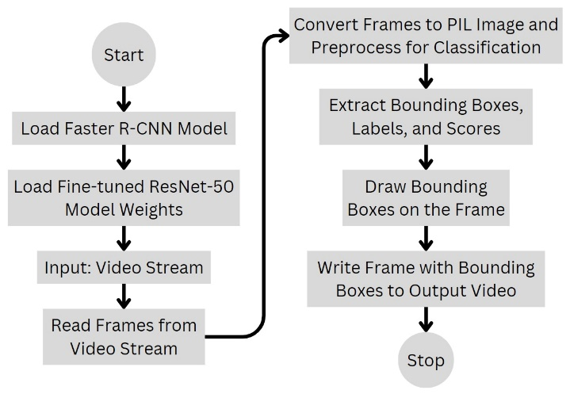
Fig. 3. Flowchart
  - Evaluation Metrics
Metrics such as tracking metrics (ATP and ATR), accuracy in motion prediction (MAE or RMSE), precision (P), sensitivity (S), F-measure, interaction over union (IoU), mean average precision (mAP), safety and efficiency metrics, and precision (P) are among the many metrics that are evaluated while evaluating a method. Sensitivity gauges how comprehensive positive predictions are, precision assesses how accurate positive predictions are, and the F-measure strikes a balance between the two. IoU calculates the intersection between the projected bounding box and the enlarged ground truth bounding box of dynamic elements that have been identified, serving as a metric to assess the precision of object localization. Metrics like ATP and ATR assess the accuracy and completeness of object tracking over time. Speed of efficiency of metrics measures the computational efficacy of the method, while MAE or RMSE measure the accuracy of motion prediction. Safety and efficiency metrics consider traffic flow, congestion reduction, and accident prevention, depending on the specific goals of the method.
Equations (3), (4), (5), and (6) compute the evaluation metrics for the proposed model: accuracy, precision, sensitivity, and F-measure.
$Accuracy=\frac{TP+TN}{TP+TN+FP+FN}$ (3)
$Precision=\frac{TP}{TP+FP}$ (4)
$Sensitivity=\frac{TP}{TP+FN}$ (5)
$F-measure=\frac{2 x TP}{\left(2 x TP\right)+FP+FN}$ (6)
In this case, TP stands for True Positive, FP for False Positive, and TN for True Negative.
- Results and Discussion
The proposed solution’s accuracy, sensitivity, and F-measure of the five classes using the suggested model are calculated. The images with the classes of pedestrians and traffic signs have a precision of 1. This indicates that the model is 100% accurate in predicting whether a lesion belongs to the category of pedestrians or traffic signs. Bikes have the lowest precision (0.95). The sensitivity value of the class Cars photos is 1, meaning that 100% of the Cars' skin lesions are accurately identified by the model. The precision/sensitivity weighted average is known as the F-measure. Therefore, both false positives and false negatives are considered in this score. Classes Traffic Signs and Cars have the maximum F-measure of 1, while Bikes have the lowest F-measure of 0.94. The model's overall average is 98.27%. In this paper, 100 epochs were run to increase the accuracy of the model used in this proposed solution. Table 2 displays the results after the model was trained over 100 epochs. Table 2 presents the findings of this system in terms of test accuracy and process interference.
Table 2. Model performance summary
No. of Epochs | Test Accuracy | Final Training Loss | Process Inference: 156 milliseconds
100 | 98.2659% | 0.0326 | ‘ASUS TUF dash Gaming F15 Core i5 12th Gen 12500H - (8 GB/512 GB SSD/4 GB Graphics/NVIDIA GeForce RTX 3050)’ machine

As time goes on, the training loss of the model drops, suggesting that it is learning from the training set (see Fig. 4). There are some variations, though, which is typical. In the first few epochs, the model has a large initial training loss, but it rapidly decreases. After 50 epochs, the loss curve reaches a plateau; an apparent overfitting may be the cause of a little uptick around epoch 90. The training data has not been overfitted by the well-trained model.
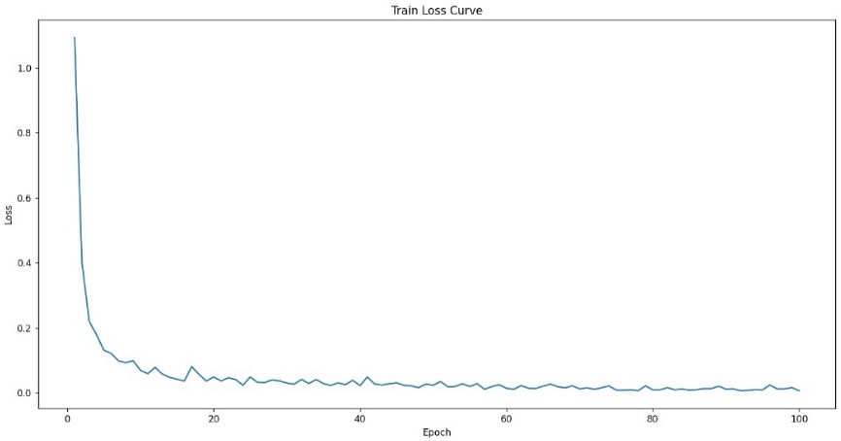
Fig. 4. Loss Function Curve after training the machine learning model over 100 epochs
‘Fine-tuning mechanism’ and ‘SGD algorithms’ were used for optimizing the results.

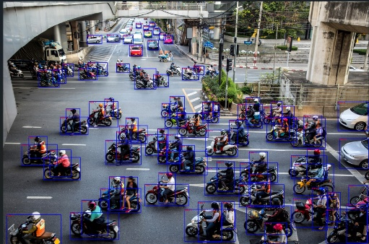
Fig. 5. Applying bounding boxes around the objects identified in the given image
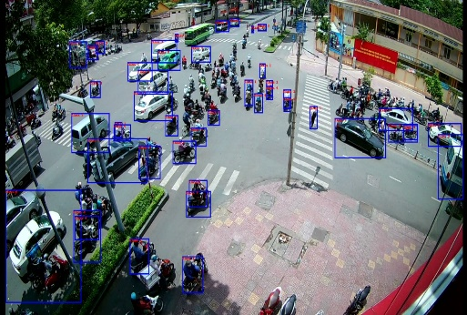
Fig. 6. Implementation of Bounding Boxes around the objects identified in the given video

All the bikes, cars, and vehicle drivers (Class 1 - Pedestrians) are detected accurately (see Fig. 5). Traffic Obstacle Detection has been applied in the dynamic video stream with the help of bounding boxes (see Fig. 6). In this case, the score threshold was set to be 0.7. Classes like Vehicle drivers (Class 1 - Pedestrians), Cars and bikes are detected everywhere except the central and left region of the image, since it is a snapshot from a dynamic video. The limitation of the proposed model could be easily observed as detection of zebra crossings and traffic signs is not visible. As vehicles like Buses and trucks were not part of the classes in the dataset, they are not being detected.
The proposed strategy was evaluated using a customized set of images sourced from publicly accessible data science datasets, featuring five distinct classes: Pedestrians, Traffic Signs, Cars, Bikes, and Zebra Crossings. 98.27% was the highest accuracy achieved using 100 Resnet-50 architecture epochs. Ten epochs were used to train the model at the beginning. The system’s overall accuracy increased from 97.55% to 98.27% when the number of epochs was increased from 10 to 100.

  - Experimental Analysis:
The lesions that the suggested model infers are present in the picture are represented by the y-axis, which shows the anticipated values. The images that the suggested model successfully predicted are displayed on the confusion matrix diagonal. As we can see, the high accuracy of 98.27% is consistent with the small number of incorrect predictions.
The proposed model is compared with the other popular object detection models using five parameters: Accuracy (mAP), Latency, Model Size, Dataset, Bounded box loss. Table 3 displays the comparison of this fine-tuned Faster R-CNN with models like Fast R-CNN, R-CNN, YOLOv5, SSD, RetinaNet.
Table 3. Related experimental work results
Model | Accuracy (mAP) | Model Size (MB) | Dataset | Bounding box Loss
Proposed Model | 91% | 92 | Customized | 0.0326
Faster R-CNN (Resnet101) | 85.60% | 200 | COCO, Pascal VOC2012 | 0.12
Fast R-CNN | 70% | 150 | Pascal VOC2007 | Smooth L1
R-CNN | 66% | 75 | Pascal VOC2007 | Smooth L1
YOLOv2 (Darknet19) | 78.60% | 35 | Pascal VOC2007 | 0.057
SSD512 (VGG16) | 80% | 25 | COCO, Pascal VOC2012 | Smooth L1
RetinaNet | 73.80% | 75 | COCO | Focal Loss

From the above Table 3 we can infer that the proposed model appears to have the highest accuracy (91%) and the lowest bounding box loss (0.0326) of all the models listed. Additionally, it has the smaller model size (92 MB). Faster R-CNN (ResNet101) offers lesser accuracy with higher model size, while YOLOv2 (Darknet19) is the fastest model and is compact with a lower accuracy (78.60%).
- Future Scope
The system's capabilities can be enhanced by incorporating traffic scene understanding and traffic scene graph understanding. This can be achieved by integrating semantic segmentation, lane detection, and traffic sign recognition for comprehensive analysis. Traffic scene graph understanding can be developed by representing the scene as a graph and incorporating temporal information for advanced reasoning. Speed of detection and processing can be improved by optimizing the model architecture, using efficient algorithms, or exploring hardware acceleration like GPUs or TPUs for real-time obstacle detection. The system should support multiple cameras for a more comprehensive view of the environment and incorporate algorithms to fuse information from different cameras for a more accurate understanding of traffic scenes. Road safety can be further improved by expanding the scope to include the detection of cyclists and pedestrians.
- Conclusion
The study uses ResNet-50 for precise localization of traffic signs, bikes, autos, and pedestrians, demonstrating advanced technology for traffic scene interpretation and control. It integrates Faster R-CNN for real-time decision-making, transforming urban transport networks. The Fine-tuned Modified Faster R-CNN system detects traffic obstacles with an accuracy rate of 98.27%. This system uses optimization techniques like Stochastic Gradient Descent, Cross-Entropy, and Fine-tuning, transforming transportation networks with a process interference time of 156 milliseconds.

References
- Wojek, Christian, Stefan Walk, Stefan Roth, Konrad Schindler, and Bernt Schiele. "Monocular visual scene understanding: Understanding multi-object traffic scenes." IEEE transactions on pattern analysis and machine intelligence 35, no. 4 (2012): 882-897.
- Li, Wei, Zhaowei Qu, Haiyu Song, Pengjie Wang, and Bo Xue. "The traffic scene understanding and prediction based on image captioning." IEEE Access 9 (2020): 1420-1427.
- Song, Lei, Zheyuan Liu, Huixian Duan, and Na Liu. "A Color-Based Image Segmentation Approach for Traffic Scene Understanding." In 2017 13th International Conference on Semantics, Knowledge and Grids (SKG), pp. 33-37. IEEE, 2017.
- Giachetti, Andrea, Marco Cappello, and Vincent Torre. "Dynamic segmentation of traffic scenes." In Proceedings of the Intelligent Vehicles' 95. Symposium, pp. 258-263. IEEE, 1995.
- Chen, Long, Shaobo Lin, Xiankai Lu, Dongpu Cao, Hangbin Wu, Chi Guo, Chun Liu, and Fei-Yue Wang. "Deep neural network based vehicle and pedestrian detection for autonomous driving: A survey." IEEE Transactions on Intelligent Transportation Systems 22, no. 6 (2021): 3234-3246.
- Murugan, V., V. R. Vijaykumar, and A. Nidhila. "A deep learning RCNN approach for vehicle recognition in traffic surveillance system." In 2019 international conference on communication and signal processing (ICCSP), pp. 0157-0160. IEEE, 2019.
- S. Bhatlawande et al., "Study of Object Detection with Faster RCNN," 2022 2nd International Conference on Intelligent Technologies (CONIT), Hubli, India, 2022, pp. 1-6.
- Tariq, Abdullah, Muhammad Zeeshan Khan, and Muhammad Usman Ghani Khan. "Real time Vehicle Detection and Colour Recognition using tuned features of Faster-RCNN." In 2021 1st International Conference on Artificial Intelligence and Data Analytics (CAIDA), pp. 262-267. IEEE, 2021.
- Ojha, Apoorva, Satya Prakash Sahu, and Deepak Kumar Dewangan. "Vehicle detection through instance segmentation using mask R-CNN for intelligent vehicle system." In 2021 5th international conference on intelligent computing and control systems (ICICCS), pp. 954-959. IEEE, 2021.
- Manana, Mduduzi, Chunling Tu, and Pius Adewale Owolawi. "Preprocessed faster RCNN for vehicle detection." In 2018 International Conference on Intelligent and Innovative Computing Applications (ICONIC), pp. 1-4. IEEE, 2018.
- Wu, Fang-Yu, Shi-Yang Yan, Jeremy S. Smith, and Bai-Ling Zhang. "Traffic scene recognition based on deep CNN and VLAD spatial pyramids." In 2017 International Conference on Machine Learning and Cybernetics (ICMLC), vol. 1, pp. 156-161. IEEE, 2017.
- Suhao, Li, Lin Jinzhao, Li Guoquan, Bai Tong, Wang Huiqian, and Pang Yu. "Vehicle type detection based on deep learning in traffic scene." Procedia computer science 131 (2018): 564-572.
- Oeljeklaus, Malte, Frank Hoffmann, and Torsten Bertram. "A fast multi-task CNN for spatial understanding of traffic scenes." In 2018 21st International Conference on Intelligent Transportation Systems (ITSC), pp. 2825-2830. IEEE, 2018.
- Deepajothi, S., D. Palanival Rajan, P. Karthikeyan, and S. Velliangiri. "Intelligent traffic management for emergency vehicles using convolutional neural network." In 2021 7th International Conference on Advanced Computing and Communication Systems (ICACCS), vol. 1, pp. 853-857. IEEE, 2021.
- Yoo, Sang-Jo. "Efficient traffic prediction scheme for real-time VBR MPEG video transmission over high-speed networks." IEEE Transactions on Broadcasting 48, no. 1 (2002): 10-18.
- Huang, Xinyu, Xinjing Cheng, Qichuan Geng, Binbin Cao, Dingfu Zhou, Peng Wang, Yuanqing Lin, and Ruigang Yang. "The apolloscape dataset for autonomous driving." In Proceedings of the IEEE conference on computer vision and pattern recognition workshops, pp. 954-960. 2018.
- Wang, Peng, Xinyu Huang, Xinjing Cheng, Dingfu Zhou, Qichuan Geng, and Ruigang Yang. "The apolloscape open dataset for autonomous driving and its application." IEEE transactions on pattern analysis and machine intelligence 1 (2019).
- Geiger, Andreas, Philip Lenz, and Raquel Urtasun. "Are we ready for autonomous driving? the kitti vision benchmark suite." In 2012 IEEE conference on computer vision and pattern recognition, pp. 3354-3361. IEEE, 2012.
- J. Madake, R. Rane, R. Rathod, A. Sayyed, S. Bhatlawande and S. Shilaskar, "Visualization of 3D Point Clouds for Vehicle Detection Based on LiDAR and Camera Fusion," 2022 OITS International Conference on Information Technology (OCIT), Bhubaneswar, India, 2022, pp. 594-598.
- Tosi, Fabio, Filippo Aleotti, Pierluigi Zama Ramirez, Matteo Poggi, Samuele Salti, Luigi Di Stefano, and Stefano Mattoccia. "Distilled semantics for comprehensive scene understanding from videos." In Proceedings of the IEEE/CVF conference on computer vision and pattern recognition, pp. 4654-4665. 2020.
- Li, Qipeng, Yuan Zhuang, and Jianzhu Huai. "Multi-sensor fusion for robust localization with moving object segmentation in complex dynamic 3D scenes." International Journal of Applied Earth Observation and Geoinformation 124 (2023): 103507.
- Gupta, Abhishek, Alagan Anpalagan, Ling Guan, and Ahmed Shaharyar Khwaja. "Deep learning for object detection and scene perception in self-driving cars: Survey, challenges, and open issues." Array 10 (2021): 100057.
- Kaggle Homepage, https://www.kaggle.com/, last accessed 2023/07/26.

